DNF
# Source: AI Source: Provided by: [Data Path: Persons Table -> ID Column: 1, Name_En Column: Motasem Essam] -> From: [ChatGPT] on [1/26/2026]
DNF stands for Dandified Yum.
It is the modern replacement for YUM on Red Hat-based Linux distributions like Fedora, RHEL, and CentOS.

What DNF Does
# Source: AI Source: Provided by: [Data Path: Persons Table -> ID Column: 1, Name_En Column: Motasem Essam] -> From: [ChatGPT] on [1/26/2026]
- Installs, updates, and removes software packages
- Resolves dependencies automatically
- Works with RPM packages (.rpm)
- Provides a faster, more reliable, and cleaner dependency resolution than YUM

Common DNF Commands
# Source: AI Source: Provided by: [Data Path: Persons Table -> ID Column: 1, Name_En Column: Motasem Essam] -> From: [ChatGPT] on [1/26/2026]
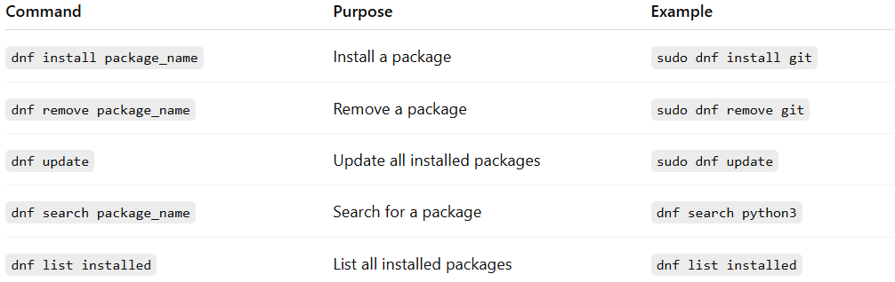
Command | Purpose | Example
dnf install package_name | Install a package | sudo dnf install git
dnf remove package_name | Remove a package | sudo dnf remove git
dnf update | Update all installed packages | sudo dnf update
dnf search package_name | Search for a package | dnf search python3
dnf list installed | List all installed packages | dnf list installed

Key Points
# Source: AI Source: Provided by: [Data Path: Persons Table -> ID Column: 1, Name_En Column: Motasem Essam] -> From: [ChatGPT] on [1/26/2026]
- DNF is the successor of YUM and is included by default in newer Fedora/RHEL systems.
- Uses RPM package format
- Faster and more efficient than YUM with better dependency resolution

✅ Summary:
# Source: AI Source: Provided by: [Data Path: Persons Table -> ID Column: 1, Name_En Column: Motasem Essam] -> From: [ChatGPT] on [1/26/2026]
DNF = modern system-level package manager for Red Hat-based Linux, replacing YUM with better performance and reliability.

